

[Artificial Intelligence in the Life Sciences 2 (2022) 10004](https://doi.org/10.1016/j.ailsci.2022.100042)2

|  |  |  |
| --- | --- | --- |
|  | Contentslistsavailableat[ScienceDirect](http://www.ScienceDirect.com) |  |
| ArtificialIntelligenceintheLifeSciences |
| journalhomepage:[www.elsevier.com/locate/ailsci](http://www.elsevier.com/locate/ailsci) |

ResearchArticle   
Anunsupervisedcomputationalpipelineidentifiespotentialrepurposable drugstotreatHuntington’sdiseaseandmultiplesclerosis   
LucaMenestrina,MaurizioRecanatini∗  
*DepartmentofPharmacyandBiotechnology,AlmaMaterStudiorum-UniversityofBologna,ViaBelmeloro6,40126Bologna,Italy*

|  |  |  |
| --- | --- | --- |
| article | info | abstract |
| *Keywords:*  Computationaldrugdiscovery Drugrepurposing  Networkpharmacology  Huntington’sdisease  Multiplesclerosis | | Drugrepurposingconsistsinidentifyingadditionalusesforknowndrugsand,sincethesenewfindingsarebuilt onpreviousknowledge,itreducesboththelengthandthecostsofthedrugdevelopment.Inthiswork,we assembledanautomatedcomputationalpipelinefordrugrepurposing,integratingalsoanetwork-basedanalysis forscreeningthepossibledrugcombinations.Theselectionofdrugsreliesbothontheirproximitytothedisease ontheprotein-proteininteractomeandontheirinfluenceontheexpressionofdisease-relatedgenes.Combined therapiesarethenprioritizedonthebasisofthedrugs’separationonthehumaninteractomeandtheknown drug-druginteractions.Weeventuallycollectedanumberofmolecules,andtheirplausiblecombinations,that couldbeproposedforthetreatmentofHuntington’sdiseaseandmultiplesclerosis.Finally,thispipelinecould potentiallyprovidenewsuggestionsalsoforothercomplexdisorders. |

**Introduction**

Discoveringanewdrugandbringingittothemarketisaprocess bothmoneyandtimeconsuming.Instead,relyingonestablisheddrugs, computationaldrugrepositioningoffersavaluablealternativeapproach forprovidingpromisingtreatmentsfordisorderswithoutacure[1,2]. Inrecentyears,aplethoraofcomputationalapproachestodrugrepur-posinghavebeenproposedandappliedtoawidevarietyoftherapeu-ticareas[3].Mostofsuchapproachesrelyeitheronmachinelearn-ingoronthetraditionalmethodsofcomputationaldrugdesign,even thoughsomeconceptuallyinnovativeideashavebroughttothelight thepossibilityoftakingnewpathstowardsthepredictionofpotentially repurposabledrugs.Oneofsuchideasisbasedonasystemviewand takesthehumanprotein-proteininteractomeasareferencenetworkto quantifytherelatednessbetweendrugsanddiseasesbycalculatingthe distancebetweendrugtargetsanddisease-associatedproteins.Thisdis-tancehasbeenproposedasasuitablemetricstomeasurethe"proximity" betweendrugsanddiseases[4].Recently,leveragingontheconceptof drug-diseaseproximity[5],noveldrugindicationsforthetreatmentof cardiovasculardiseases[5,6],cancers[7],COVID-19[8],Alzheimer’s disease[9]havebeenproposed,demonstratinghowanetwork-based approachcouldsuccessfullyassisttheselectionofdrugstoberepur-posed.

Inthiswork,weassembledanautomatedcomputationalpipelineby integratingarecentlydevelopedschemetoscreenrepurposabledrugs thatcombinesanetwork-basedtechniquewithananalysisofbiologi-

∗Corresponding[author.](mailto:maurizio.recanatini@unibo.it)

*E-mailaddress:*[maurizio.recanatini@unibo.it](mailto:maurizio.recanatini@unibo.it)(M.Recanatini).

calandexperimentaldata[10,11],withastrategyforfilteringallthe possibledrugcombinations[6].Initially,theprocedureestimatesthe proximitybetweenthedisease-relatedproteinsandthedrugtargetson theprotein-proteininteractome,performingafirstselectionofcandi-dates.Then,onlythosedrugsthatsignificantlyinfluencetheexpression ofdisease-relatedgenesareconsideredplausibleforrepurposing.Fi-nally,evaluatingtheseparationofthesedrugs’targetsonthehuman interactomeandtakingintoconsiderationtheknowndrug-druginter-actions,combinedtherapiesareprioritized.Theworkflowofthepro-cedureisschematicallyillustratedinFig.1.Theentireprocessisau-tomatedinordertoreducehumanintervention,thusacceleratingthe wholeprocedureandlimitingexecutionerrors.

WeappliedthispipelinetoHuntington’sdisease(HD)andmultiple sclerosis(MS)because,despitethefactthattheyarebothneurologi-caldisorders,theirdifferentnaturecouldrepresentachallengeforour strategy,andtheoutcomescouldgiveusinsightsintoitsmethodolog-icalstrengthsandlimitations.HD,isreportedasatypicalmonogenic disease,eventhoughmanyothergenesareknowntoinfluenceitspro-gression[12],whileforMSasinglegeneticcausehasnotbeenfound yet,probablybecausemanyfactorsplayanimportantroleintheetiol-ogy.Indeed,MSfitswellthedefinitionofcomplexdiseasetobeconsid-eredintheframeworkofnetworkmedicine.Ontheotherhand,HDwas includedinourstudyinordertotestthecapabilitiesoftheproposed methodinacasewheredifferentclinicalphenotypesmightberelated toadiseasemoduleeventuallyinfluencedbygeneticmodifiersleading todifferentpathophysiologicalstates[12–14].

<https://doi.org/10.1016/j.ailsci.2022.100042>  
[Received4May2022;Receivedinrevisedfor](https://doi.org/10.1016/j.ailsci.2022.100042)m23June2022;Accepted20July2022   
Availableonline27July2022   
[2667-3185/© 2022TheAuthors.PublishedbyElsevi](http://creativecommons.org/licenses/by-nc-nd/4.0/)erB.V.ThisisanopenaccessarticleundertheCCBY-NC-NDlicense (<http://creativecommons.org/licenses/by-nc-nd/4.0/>)

*L.MenestrinaandM.Recanatini*  *ArtificialIntelligenceintheLifeSciences2(2022)100042*

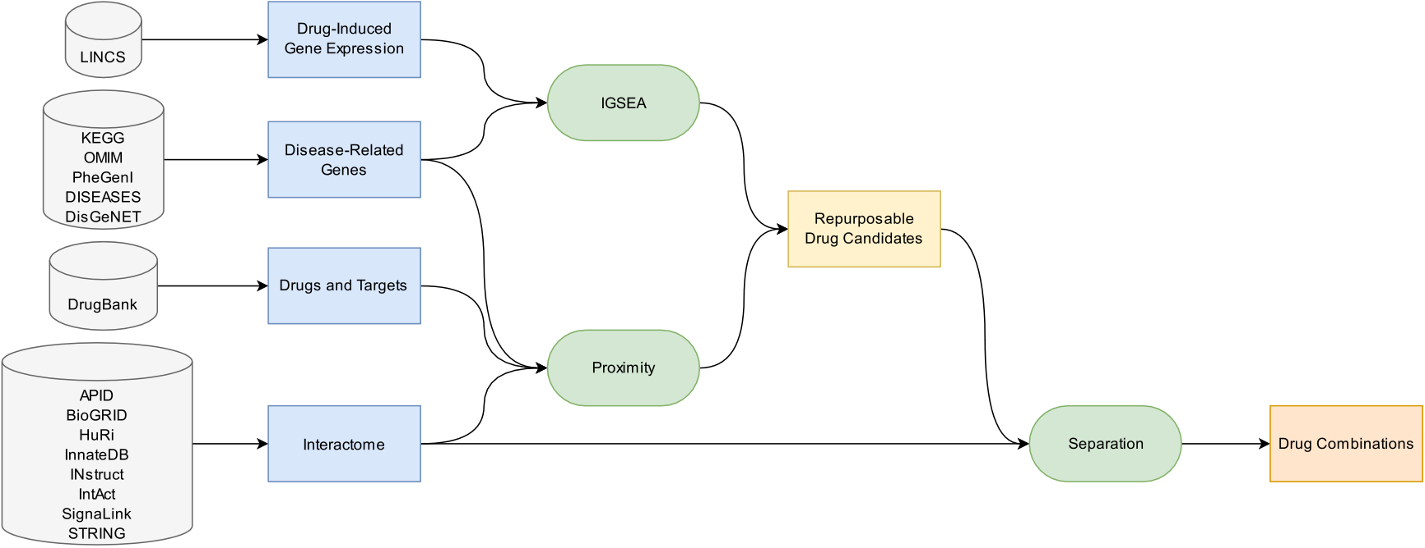

**Fig.1.**PipelineFlowchart.Theflowchartshowsthesourcesandthestepsoftheautomatedproceduretoscreenrepurposabledrugcandidatesandprioritizetheir

combinations.

HDisthemostcommonmonogenicneurologicaldisorder.Theon-setistypicallyintheearlystageofadultlife,anditischaracterized bymotordysfunction,cognitiveimpairment,andneuropsychiatricfea-tures[12,15].TheautosomaldominantmutationthatcausesHDislo-catedinthe*HTT*gene,anditconsistsinacytosine-adenosine-guanine trinucleotiderepetition(CAG,encodingglutamine)leadingtoanover-expansionofthepolyglutamine(polyQ)tailinthehuntingtinprotein. Themutatedproteintendstoaggregateandaccumulate,forminginclu-sionbodiesthathavedeleteriousconsequencesfortheneuralcell.Both theinclusionbodiesandthelengthoftheCAGexpansionareproven toplayanimportantroleinthedevelopmentofthedisease.Theclear-anceofthefirstonesslowstheHDprogression,whilethelongerthe CAGexpansion,theearlierthediseasemaymanifest[15].Theremain-inguncertaintyonthecourseofHDcanbeascribedtoothergenetic differencesinthegenomeofthepatients[12,14].

MSisboththemostfrequentnon-traumaticdisablingdiseasein youngadults[16]andthecommonestdemyelinatingdisease[17].The etiologyandthemechanismcausingitsworseningprogressionarestill unclear,neverthelessithasbeenproventhatacomplexinterplayofge-neticandenvironmentalfactorsisimportant[18,19].Themainknown riskfactorsaresmoking,childhoodobesity,infectionwiththeEpstein-Barrvirus,andlowvitaminDlevels[19].MSisgenerallyviewedasa two-phasesautoimmunedisease,inwhichinitiallyfocalinflammatory processescausearelapsing-remittingformofthedisease,andsubse-quentlydemyelinatingplaques(lesionsresultedbythepreviousimmune response)andoligodendrocytedamageleadtoneurodegenerationand non-relapsingprogressivecourse[17,19].MSiscommonlycharacter-izedbyprogressivespasticparaparesis,cognitiveimpairment,andsen-soryandcerebellardysfunctions[19].

BothHDandMSarestilllackingresolutivetreatments[20,21], whosedevelopmentneedsadeeperknowledgeoftheunderlyingmech-anisms[22].Tothisaim,network-basedmodels,astheonesweutilized inthisstudy,couldbeadequatetheoreticaltoolsforinvestigatingsuch multifactorialdisorders.Theywouldallowustotakeintoaccountthe latentcomplexstructureofthesediseaseswithoutlosingacomprehen-siveview[23].Throughthemethodologypresentedhere,wewereable tocollectanumberofapproveddrugsandtheirplausiblecombinations thatcouldbeproposedforthetreatmentofHDandMS.

**Materialsandmethods**

Theworkflowofthisstudycanbeoutlinedinthefollowingsteps (Fig.1):(1)collectionofdisease-relatedgenes;(2)genesetsvalidation throughenrichmentanalysis;(3)collectionofdrugs,targets,protein interactiondata,andconstructionofprotein-proteininteractome;(4)

2

*L.MenestrinaandM.Recanatini*

*Drugsandtargetscollection,geneexpressionprofilesretrievaland protein-proteininteractomeconstruction*

DrugsinformationwascollectedfromDrugBank[33](version 5.1.9).Onlythosemoleculeshavingatleastonehumanproteinastarget areconsidered,obtaining5798drugsand2755correspondingtargets. Drug-inducedgeneexpressionprofileswereretrievedfromtheLi-braryofIntegratedNetwork-basedCellularSignatures[34](LINCS,pro-files“GSE70138” and“GS[E92742”),downloadedfromGen](http://www.ncbi.nlm.nih.gov/geo)eExpres-sionOmnibus[35](GEO,<http://www.ncbi.nlm.nih.gov/geo>).Dueto thefactthatweareinspec[tingneurologicaldisorders,thoses](http://www.ncbi.nlm.nih.gov/geo)ignatures testedonneuralcelllines(NEU,NPC,SHSY5Y)wereexaminedforboth diseases.Additionally,inordertoconsiderdisease-specificfeatures,also muscularcelllines(SKB,SKL)wereincludedforHD,andhaematopoi-eticandlymphoidtissuecelllines(L60,JURKAT,NOMO1,PL21,SKM1, THP1,U937,WSUDLCL2)forMS.Furthermore,toguaranteemaximum reliabilityoftheresults,onlythedataabouttheBestInferredGenes (BING)ineverydataset(drugsignature)intheseprofileswaskept.The BINGsubsetincludes978landmarkgenesand9196inferredgenes, whichareidentifiedamongthe12328genesintheL1000assayby Subramanianetal.[36]evaluatingthemostreliableinferencepredic-tions.

Extensiveinteractionsamongproteinsareakeyfactorinaccom-plishingmanybiologicalprocessesandfunctions.Forthisreason, weoptedforanetwork-basedapproachtoevaluatethecorrelation betweendrugsanddiseasesordrugsandotherdrugs.Webuiltahuman protein-proteininteraction(PPI)networkcombiningdatafromeight publiclyavailable[resources:AgileProteinInteractomesDataServe](http://cicblade.dep.usal.es:8080/APID/init.action)r [37] (APID,   
 <http://cicblade.dep.usal.es:8080/APID/init.action>), Biologica[lGeneralRepository](https://thebiogrid.org/)[forInteractionDatasets[38](B](http://cicblade.dep.usal.es:8080/APID/init.action)i-oGRID,<https://thebiogrid.org/>[),TheHumanRefere](http://www.interactome-atlas.org/)nceInterac-[tome[3](http://instruct.yulab.org/)[9](HuRI,http://ww](https://thebiogrid.org/)[w.interactome-atlas.org/),InnateDB [40](https://www.innatedb.com/),INstruct[41](http://instruct. yulab.org/),IntAct[42](https://www.ebi.ac.uk/intact/home),Sig-naLink[43](http://signalink.org/),andSearchToolfortheRetrieval](http://instruct.yulab.org/) ofInteracting[Genes/Proteins[44](http://signalink.org/)](STRING,<https://string-db.org/>). SupplementaryTable1givesadditionalinfo[abouttheinteraction](https://string-db.org/)s reportedinthedatabasesandtheappliedfilters.

Theretrievedinteractionswerethencombined,obtaininganet-work(availableintheSupplementaryInformation)consistingof20445 nodes(genes/proteins)and1125173edges(interactions).Consistency isgrantedbythefactthatalllistedproteinsaremappedtoofficial genesymbolstakingadvantageoftheNCBIdatabase.Sincetheprotein-proteininteractomeisthesupportingpillarofthewholeprocedure,we assesseditsvaliditycomparingtheresultsoftheentireanalysesbased ontwootherinteractomes.Thefirstrerunwascarriedoutonthewidely recognizedinteractomefromChengetal.[5](16677uniqueproteins and243603experimentallyconfirmedprotein–proteininteractions). Thesecondonewasperformedonadrasticallyrestrictedversionofour owninteractome(16954proteinsand246080interactions),inwhich onlyinteractionsfromlowthroughputstudies(listinglessthan20in-teractions)wereincluded.

*Networkproximity*

Proteinsrelatedtoaspecificdiseaseareunlikelytobescattered throughouttheinteractome,rather,theytendtogrouptogetherforming theso-calleddiseasemodule[45].Therelationshipbetweenadrugand adiseasecouldbeestimatedbymeansofanunsupervisedandunbiased network-basedapproach[4],whichquantifiestheinterplayofdrugtar-getsanddisease-relatedgenesmeasuringanetworkproximity.Herewe usedarecentlymodifiedversionofsuchmethod[10]thatincludesa term(*𝑤*)fortakingintoaccountthedegreeofthedrugtargetsdirectly intothedistancecalculation.Given*𝐺*,thesetofdisease-relatedgenes; *𝑇*,thesetofdrugtargets;and*𝑑*(*𝑔,𝑡*),theshortestpathlengthbetween nodes*𝑔* (*𝑔*∈ *𝐺*)and*𝑡*(*𝑡*∈ *𝑇*)inthehumanprotein-proteininteractome;

3

*L.MenestrinaandM.Recanatini*  *ArtificialIntelligenceintheLifeSciences2(2022)100042*

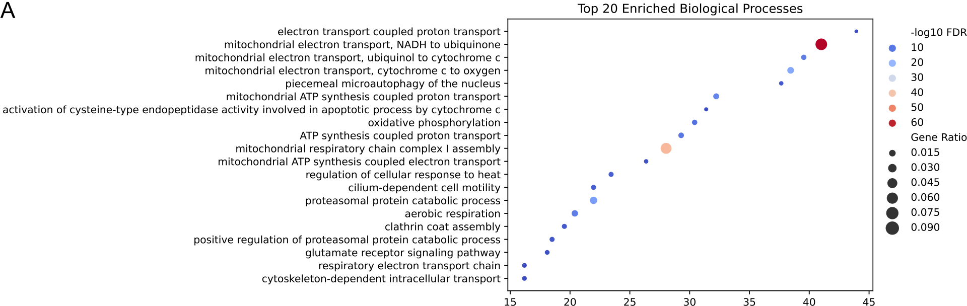



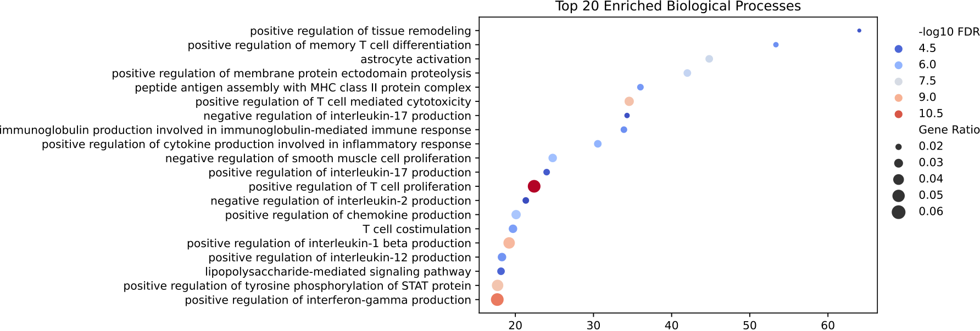



**Fig.2.**EnrichedBiologicalProcesses.Thebubbleplotsdisplaythetop20mostenrichedGeneOntologytermsrelativetobiologicalprocessesforHuntington’sdisease (A)andmultiplesclerosis(B).Onthehorizontalaxis,thefoldenrichmentisshown.Thecolorencodesthenegativeofthefalsediscoveryratelogarithm,andthe sizerepresentsthegeneratio(computedastheratioofthepercentageofgenesinthestudysetrelatedtoaspecificterm,dividedbythecorrespondingpercentage inthebackground,i.e.,theentirehumanproteome).

**Results**

*Computationalframework*

Inthisstudy,weautomatedthepipelineshowninFig.1forscreening repurposabledrugcandidatesandprioritizingtheircombinations.Inor-dertorun,thescriptonlyrequiresthediseasename,thedisease-related genes,andthecelllinesofinterestasinputs.Thisprocedureconsists of:collecting,cleaningandorganizingthesourcedata(disease-related genes,drugs,targets,proteininteractions,drug-inducedgeneexpres-sionsignatures);identifyingrepurposabledrugcandidatesevaluating boththeirproximitytothediseaseandtheireffectontheexpressionof thedisease-relatedgenes;screeningthepossibledrugcombinationson thebasisoftheirrelativeexposureandknowninteractions.Theoutput oftheroutineisacollectionoftables(tab-separatedvaluesfiles)and plots,recordingbothintermediateandfinalresults.

Comparedtopreviousrelatedworks[10,11],suchasystematicstrat-egyshouldbemoreefficientandhaveanimprovedreproducibility thankstotheorganizationandstandardizationofboththeoverallstudy andresults.Additionally,ittakesastepforwardsinceitevaluatesalso possiblecombinedtherapies.

Thesinglestepsandtheoutcomesoftheapplicationoftheframe-worktoHDandMSarepresentedanddiscussedinthefollow-ing.

*Disease-relatedgenescollectionandvalidation*

Wegatheredthedisease-relatedgenesasdescribedintheMethods section:thisresultedin451and217genesassociatedtoHDandMS,

4

*L.MenestrinaandM.Recanatini*  *ArtificialIntelligenceintheLifeSciences2(2022)100042*

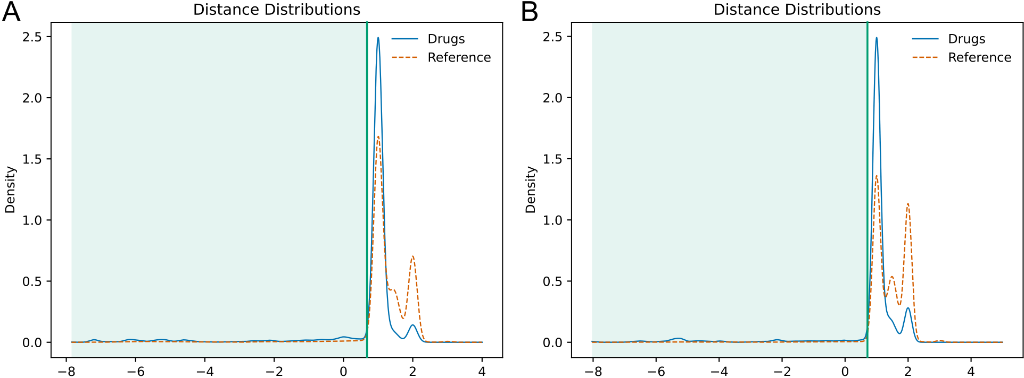

 

**Fig.3.**DistanceDistributions.Thedistributionofthedistancebetweendrugtargetsanddisease-relatedproteins(solidblueline)comparedtothatofareference

collection(dashedorangeline),forHuntington’sdisease(A)andmultiplesclerosis(B).Ontheverticalaxis,thekerneldensityestimationofthedistributionisshown.

Theplotisdividedintotwopartsbythechosendistancethreshold(greenline,seeMethods).

*Repurposabledrugsselection*

Thenetwork-basedproximityanalysis,leveragingonthepotential ofasystemview,couldsuggestvaluabledrugsabletointerferewith thediseasemoleculardeterminantsinanon-trivialway(i.e.,notonly directlytargetingdisease-relatedgenes).Theideabehindthismethod isthatdrugsproximaltothediseasemoduleshouldbemoreeffec-tivethandistantones,asshownbyGuneyetal.inanextensiveanal-ysisthatconsideredknowndiseasesanddisease-associatedgenes,as wellasdrugsandtheirtargets[4].FollowingPeng’sprotocol[10], theprocedurecomparesthedistributionofthedistancesbetweendrug targetsanddisease-relatedproteinstothatofareferencecollection (seeMethodsandFig.3).Forbothdiseases,itwaspossibletoiden-tifyadistancevaluebelowwhichthetwodensitycurves(drugsand reference)dropdramatically.Inparticular,thereferencedensityas-sumesnegligiblevaluesfordistancesbelowthispoint(Fig.3,green partoftheplot).Weelectedsuchdistancevalue(Fig.3,vertical greenline)asthethresholdtodiscriminatedrugsassociatedtothedis-eases.Thesedistancesare0.68and0.71(correspondingtoproximity:−0.53and–0.98)forHDandMS,respectively.Fromthisanalysis,685 (11.8%)outofthe5798drugscollectedfromDrugBankwereconsid-eredsignificantlyproximalmedicamentsforHD,and475(8.2%)for MS.

Inordertoevaluatetheimpactofadrugonthedisease,weexamined theeffectofitsadministrationontheexpressionofthedisease-related genesinrelevantcelllines(seeMethods).Wepursuedthisobjective byperforminganInvertedGeneSetEnrichmentAnalysis(IGSEA)on 896drugs,observedin6212LINCSexpressiondatasetsforHDand960 drugsin5579datasetsforMS.Thisanalysisresultedin843and600 significantlyenricheddrugs,forHDandMSrespectively.

Thedrugsthatwerebothsignificantlyenrichedandproximalto thediseaseweredeemedtoberepurposabledrugcandidates:138for HDand38forMS(SupplementaryTables2,3).Theinteractionsbe-tweentheMS-related-genes,thedrugtargets,andtherepurposabledrug candidatesarevisualizedinFig.4(andSupplementaryFigure4for HD),showinghowdrugscanberelatedtothediseasethroughtheir targets.

Unfortunately,onlyasmallportionoftheproximaldrugshasdata intheLINCSdatabase(21.9%forHDand13.7%forMS).Eventhough theIGSEAanalysisincreasesthereliabilityoftheresults,itdramatically reducesthenumberofmoleculesthatcanbeinvestigatedandpossibly proposed.Thishastobetakenintoaccountwhenevaluatingtheout-comesofthestudy.

5

*L.MenestrinaandM.Recanatini*  *ArtificialIntelligenceintheLifeSciences2(2022)100042*

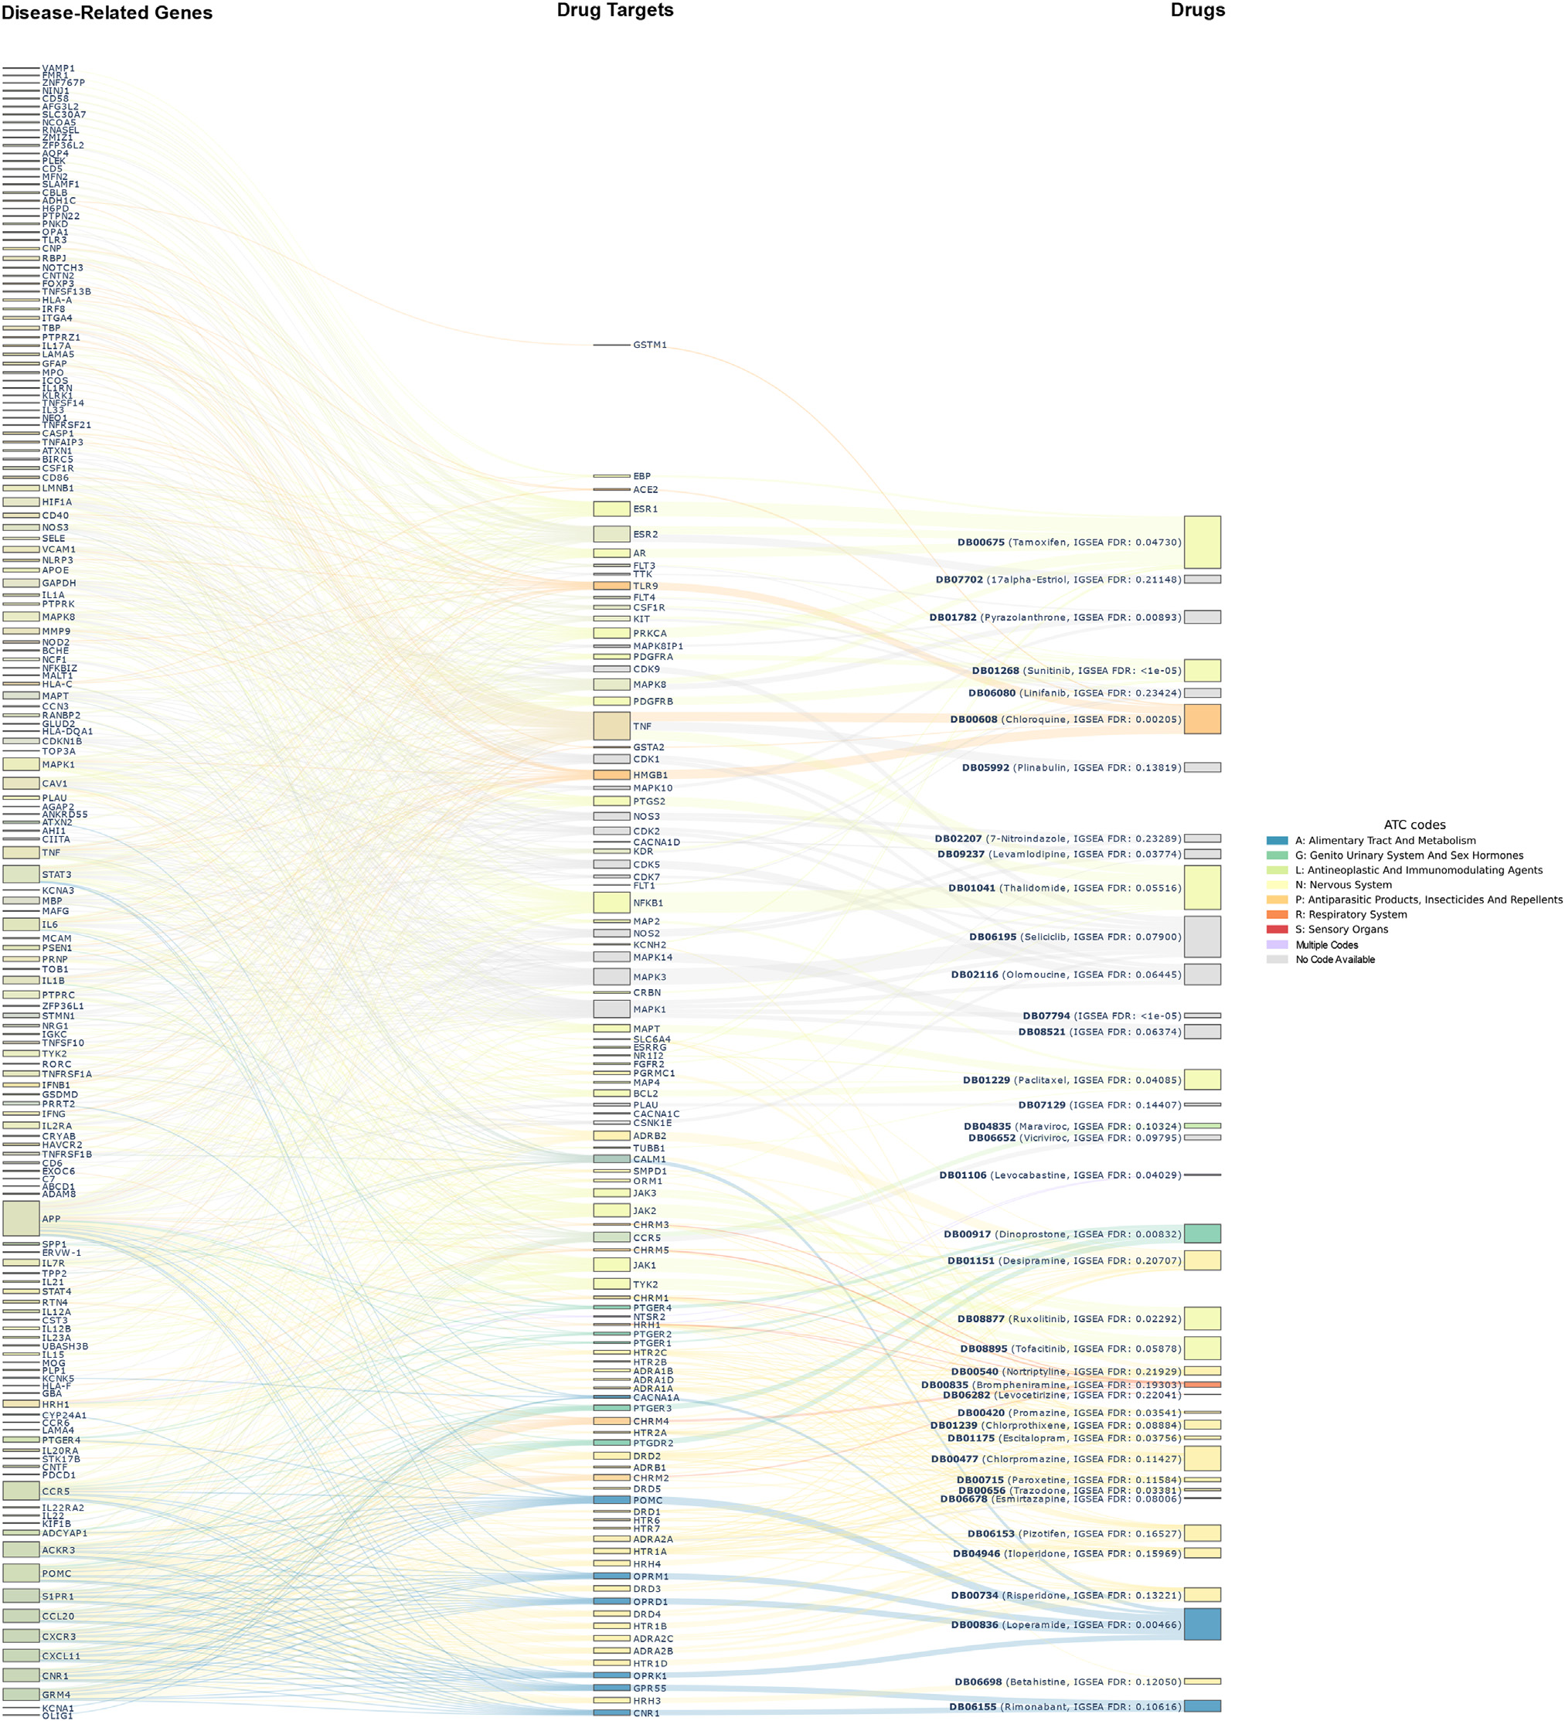

**Fig.4.**MultipleSclerosisGene-Target-DrugNetwork.TheSankeydiagramillustratestheinterconnectionsbetweendisease-relatedgenes,drugtargets,anddrugs.

Eachdrug(rightcolumn)isconnectedtoitsreportedtargets(middlecolumn),which,inturn,areproximalonthehumaninteractometosomeofthedisease-associated

proteins(leftcolumn).DrugsarecoloredbytherespectiveATCcode,andtheFDRoftheIGSEAanalysis(seeMethods)isreportedinthelabel.

creasedperformance,whichisperfectlyinlinewiththeBigDataper-spective[47].

*Repurposabledrugs*

AmongthedrugsselectedtotackleHD(138),several(17)havebeen clinicallytestedandsuggested,manyshowstrongevidencefrominvivo tests(35)orpromisingresultsfrominvitroassays(9).Allthereferences arereportedintheSupplementaryTable2,themostnoticeableexam-

6

*L.MenestrinaandM.Recanatini*  *ArtificialIntelligenceintheLifeSciences2(2022)100042*

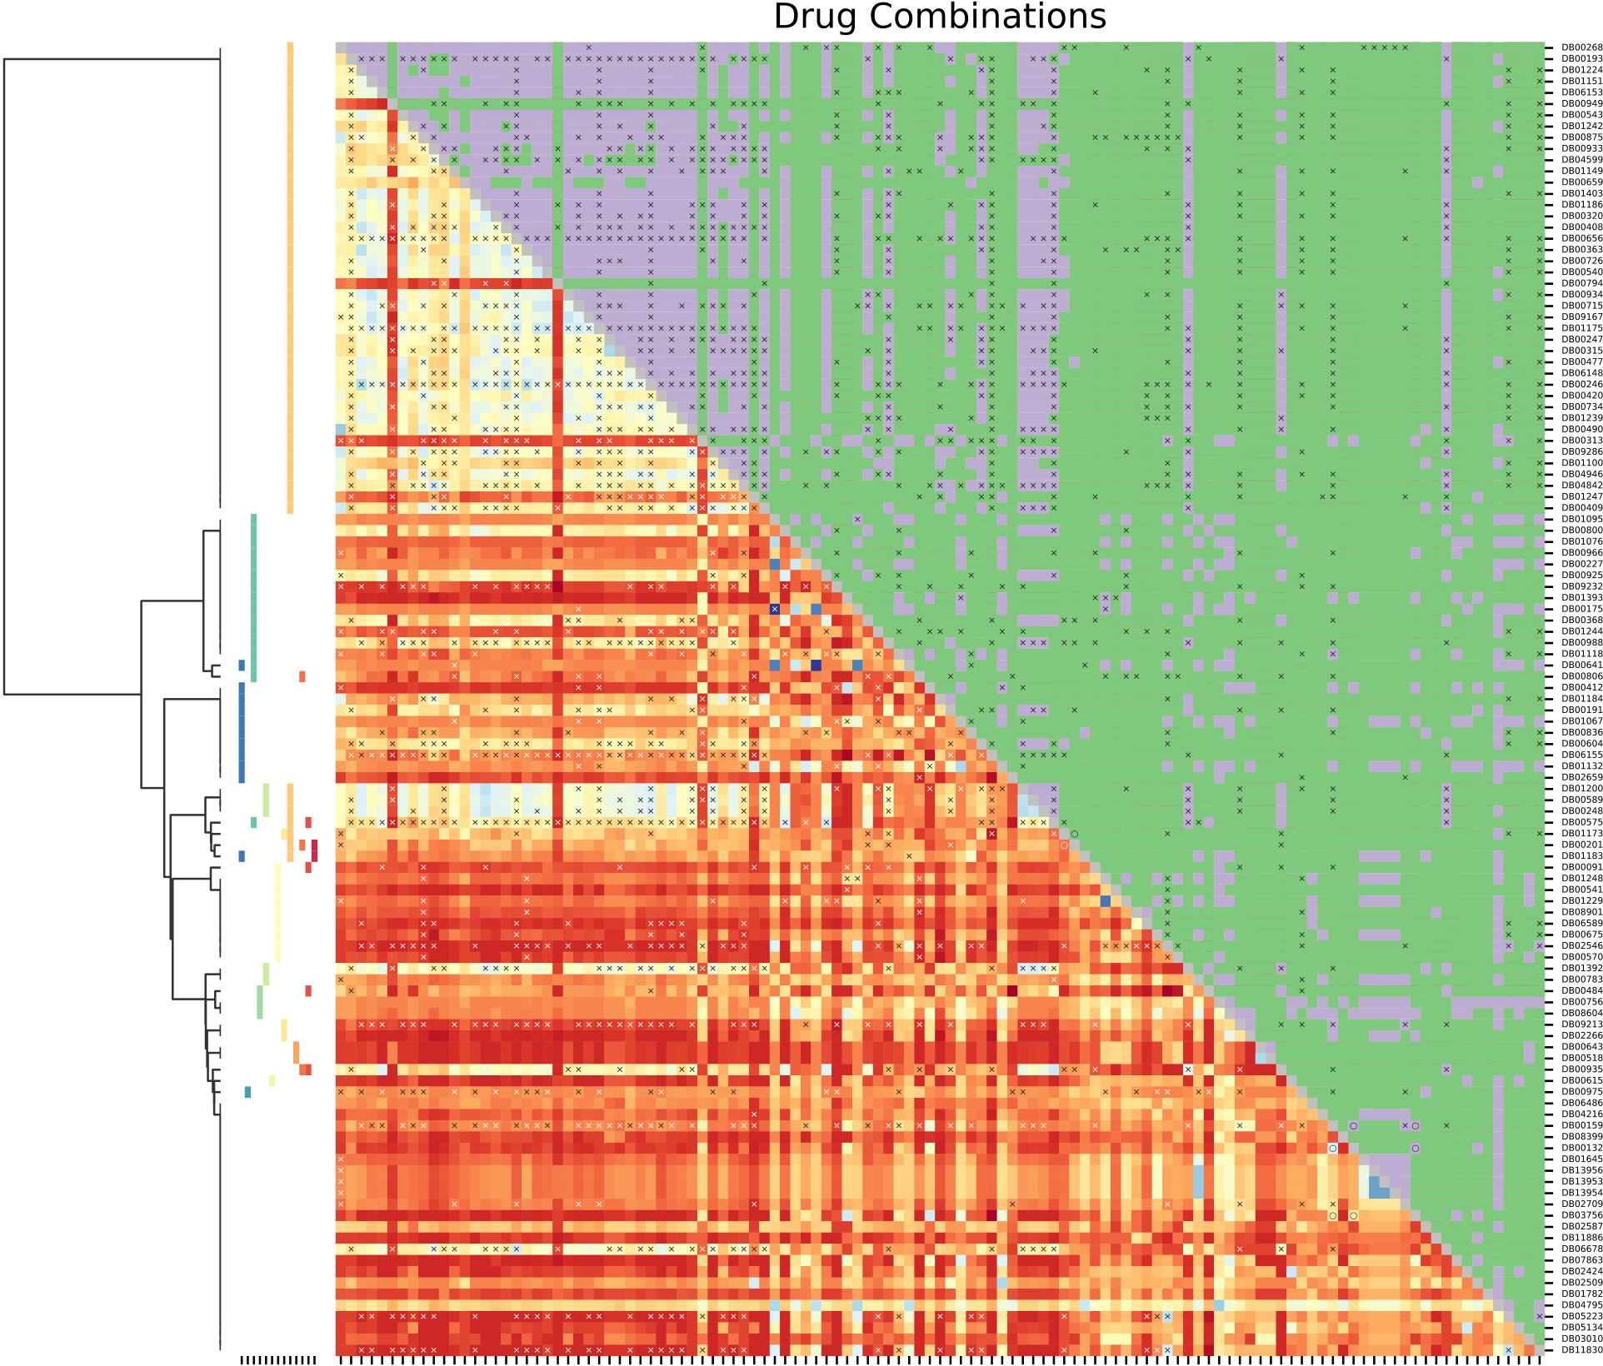



|  |  |  |  |  |
| --- | --- | --- | --- | --- |
|  | | | |  |
|  |  |  |  |



 

 

 



|  |  |
| --- | --- |
|  |  |



**Fig.5.**Huntington’sDiseaseDrugCombinations.Theannotatedheatmapprovidesinfoaboutpossiblecombinationsoftheselecteddrugs.Acombinationismarked with× ifaninteractionisreportedinDrugBank,andwith○ ifitispresentinanapprovedformulation.Thelower-leftpartoftheheatmapshowstheseparation oftheinspecteddrugs,colorcodedfromblue(noseparation)tored(stronglyseparated).Theupper-rightportion,instead,displaysthekindofexposure:violetif overlappingandgreenifcomplementary.Attheleftmostpart,theATCcodesofthedrugsarereportedalongwithadendrogramoftheirhierarchicalclustering.

hasbeneficialeffectsinthetreatmentofpsychiatricmanifestationsand stabilizationofmotorsymptomsinpatientswithHD[20].

InspectingthedrugsscreenedforMS(38),weobtainedacomparable outcome:7ofthemareclinicallystudiedand9experimentedonanimal models.AlltheevidenceislistedintheSupplementaryTable3.Most

7

*L.MenestrinaandM.Recanatini*

ExaminingtheAnatomicalTherapeuticChemical(ATC)codesofthe repurposabledrugs,thefirstthingtonoticeisthepredictablepreva-lenceofdrugsassociatedtotheATCcodeN(NervousSystem)forboth diseases.Apartfromthis,themostcommoncodesforHDrepurposable drugsareC(Cardiovascular)andL(AntineoplasticandImmunomodu-latingAgents).Thefirstgroupismainlyrepresentedbystatins,usedto copewiththecholesterolimpairmenttypicalofHDpatients[52].The immunomodulatingagentsareprincipallyimmunosuppressantsandhi-stonedeacetylasesinhibitors,thelastonesaimedatrecoveringfromthe histonehypoacetylationcommoninneurologicaldisorders[53]. ForMS,instead,thesecondmostfrequentcodeisL(Antineoplastic andImmunomodulatingAgents).Somerelevantexamplesareruxoli-tinib,paclitaxel,tamoxifen,andthalidomide,whicharecapableofat-tenuatingexperimentalautoimmuneencephalomyelitisandofinducing remyelination[54–58].

*Drugcombinations*

Observingtheobtainedresults(depictedasannotatedheatmapsin Fig.5forHDandSupplementaryFigure5forMS)itisinterestingto

*ArtificialIntelligenceintheLifeSciences2(2022)100042*

highlightthatdrugsthatdonothaveATCcodesassociatedtothemare alsothosewithfew(ornothingatall)reportedinteractions.Thissug-geststhattheyarenotsufficientlycharacterizedandadditionalstudies onthemareneededbeforefurtherconsideration.

Thecollectedplausiblecombinationsarenumerous,buttheassoci-ationoforphenadrine(DB01173)andcaffeine(DB00201)forHDde-servestobehighlighted.Thesemoleculesarepresentalongwithacetyl-salicylicacid(ASA)inanFDAapprovedformulationformuscularpain relief.Thismedicationisnoteworthyformanyreasons.Firstofall, painisaknownissueinHDandcouldbeanimportantnon-motor symptom[59,60]thus,itstreatmentshouldnotbeneglected.Further-more,orphenadrineshowedtobeeffectiveinpreventingneurotoxicity inratswithachemically-inducedconditionthatmimicsthehistologi-calandneurochemicalfeaturesofHD[61].Additionally,lowdosages ofcaffeineshowedtobebeneficialinHDanimalmodels[62].Finally, ASAwasincludedintheformulationforrelievingpainanddecreasing swelling.EventhoughASAwasproximaltoHD,itwasnotincludedin ourresultsbecauseitsdatawasnotavailableinLINCSfortheinvesti-gatedcelllines.However,itisactuallyprofitableforthepresentaim, sinceitshowedtopreventproteinaggregationinseveralneurodegen-

|  |  |
| --- | --- |
|  | **Fig.6.**EscitalopramandTofacitinibComple-mentaryExposure.Thenetworkdisplaysthe proteinsassociatedtoMS(circles)andhigh-lightsthosetargetedbyescitalopramandtofac-itinib(darkgreenanddarkblue,respectively). TargetsthatarenotrelatedtoMSareindicated astriangles.Inordertobetterillustratethein-fluenceofthesetwomoleculesgivenbythe tightinterconnectionoftheproteome,thefirst neighborsofthedrugtargetsaredepictedin alightercolor(lightgreenforneighborsoftar-getsofescitalopram,andlightbluetofacitinib’s ones). |

8

*L.MenestrinaandM.Recanatini*

erativediseases[63].Furtherassessmentsareneeded,butthiscouldbe aninterestingpointwheretostart.

AreasonablehypothesisfortreatingMSmightbeanassociation oftwodrugssufficientlyseparatedfromeachotherasescitalopram (DB01175)andtofacitinib(DB08895)orruxolitinib(DB08877),capa-bleofaffectingcomplementarypartsofthediseasemodule.Fig.6shows thenetworkoftheinteractionsamongproteinsassociatedtoMS(allcir-cles)andhighlightsthosetargetedbyescitalopramandtofacitinib(dark greenanddarkblue,respectively).Amongthesetargets,twoofthem, namelyHRH1forescitalopram(darkgreencircle)andTYK2fortofac-itinib(darkbluecircle),belongtotheMSdiseasemodule,whilethose thatarenotdirectlyrelatedtoMSaredepictedastriangles(maintain-ingthesamecolorcoding).Inordertobetterillustratetheinfluenceon thediseasemoduleofthetwodrugsintermsofprotein-proteininter-actions,thefirstneighborsofthedrugtargetsarecoloredlighter(light greenforneighborsoftargetsofescitalopram,andlightbluefortofaci-tinib’sones).Itcanbeseenthatoverallthetargetsofbothescitalopram andtofacitinibortheirfirstneighborscaninfluenceareasonablepartof thediseasemodulewithoutredundantlyinterferingwiththesameMS proteins.Infact,ouranalysisshowedthatthesedrugsareproximalto MSandsignificantlyinfluenceproteinsassociatedtothisdisease.Addi-tionally,nointeractionsbetweenthemhavebeenreportedinDrugBank. Moreover,wefoundexperimentalevidencesupportingthisinference. Escitalopramisaselectiveserotoninre-uptakeinhibitor(ATCcode:N, Nervous)thatinhumansprovedtopreventstress-relatedrelapses[51]. Tofacitinibandruxolitinibshowedpromisingeffectsinanimalmodels: thefirstoneenhancingremyelinationandimprovingmyelinintegrity [64],andthesecondoneamelioratingtheseverityofthedisease[54]. Furthermore,theyareJanuskinase(JAK)inhibitors(ATCcode:L,Anti-neoplasticandImmunomodulatingAgents)andtheJAK/STATpathway isaberrantlyactivatedinMS[21,65].

Intheotherdrugcombinations,whicharesufficientlyseparated(see Methods,greenontheheatmaps)andforwhichnoadverseinteractions arereported(notannotatedwithan× intheheatmaps),valuableclues forpolypharmacologicalinterventionscouldbefound.Aworkinghy-pothesismightbetochoosetwodrugstacklingdifferentaspectsofa disease,forinstancefeaturingdistinctATCcodes.

**Limitations**

Despiteourbestefforts,thisstudyisnotexemptfromsomeshort-comingsthatarecommonindataanalysis,andregardmainlythedata availabilityandquality.Thiscouldhaveledustomisssomepromis-ingcompoundsand,atthesametime,itmaycompromisesomeofthe analyses.

Acompletecharacterizationofallavailabledrugsandhumanpro-teinsissurelynotathand,andthishasrepercussionsonmanyaspects ofthestudy,like,e.g.,thehumanprotein-proteininteractomecon-struction,drugassociationtobiologicalprocesses,cellularcomponents, molecularfunctionsandphenotypes,anddruginducedgeneexpression profilesretrieval.Onlysometimes,thisissuecouldbepartiallymitigated byanextensiveintegrationofdatafromawidervarietyofdatabases. Noteworthy,puzzlingexamplescouldbethedrug-targetassociationand theavailabilityofexpressiondatainLINCS.Thenumberoftargetsas-sociatedtoaspecificdrugcouldconsiderablydependontheamount ofresearchcarriedoutonthatmedicineratherthanontheactualbi-ologicalinteractionsithas.Thisinfluencesthedrug-diseaseproximity evaluation.Additionally,asstatedabove,theLINCSdatabasedoesnot provideexpressionprofilesforallthedrugsselectedbynetworkprox-imity,limitingbyfarthechoicespacefordrugrepurposing.

Furthermore,iftheknowledgewehaveaboutdrugsisincomplete, theonewehaveontheircombinationisevensparser.This,obviously, affectsourabilitytoscreenandjudgeplausibleassociations.

Moreover,itcouldbearguedthat,eventhoughthedrug-disease proximityisevaluatedwitharigorousgeometricalapproach,thechoice

9

*L.MenestrinaandM.Recanatini*

[10]PengY,YuanM,XinJ,LiuX,WangJ.Screeningnoveldrugcandidatesfor Alzheimer’sdiseasebyanint[egratednetworkandtranscriptom](https://doi.org/10.1093/bioinformatics/btaa563)eanalysis.Bioinfor-matics2020;36:4626–32.doi[:10.1093/bioinformatics/btaa563.](https://doi.org/10.1093/bioinformatics/btaa563)

[11]QuanP,WangK,YanS,et[al.Integratednetworkanalysisi](https://doi.org/10.1093/bioinformatics/btaa563)dentifyingpotential nov[eldrugcandidatesandtargets](https://doi.org/10.1038/s41598-021-92701-2)forParkinson’sdisease.SciRep2021;11:13154. doi[:10.1038/s41598-021-92701-2.](https://doi.org/10.1038/s41598-021-92701-2)

[12]Bat[esGP,DorseyR,GusellaJF,](https://doi.org/10.1038/s41598-021-92701-2)[etal.](https://doi.org/10.1038/nrdp.2015.5)Huntingtondisease.NatRevDisPrim 2015;1:15005.doi[:10.1038/nrdp.2015.5.](https://doi.org/10.1038/nrdp.2015.5)

[13]LoscalzoJ,Kohane[I,BarabasiAL.Huma](https://doi.org/10.1038/nrdp.2015.5)ndiseaseclassificationinthepostgenomic era:[acomplexsystemsapp](https://doi.org/10.1038/MSB4100163)roachtohumanpathobiology.MolSystBiol2007;3:124. doi[:10.1038/MSB4100163.](https://doi.org/10.1038/MSB4100163)

[14]Wri[ghtGEB,BlackHF,Col](https://doi.org/10.1038/MSB4100163)linsJA,etal.Interruptingsequencevariantsandageof onsetinHuntington’sdisea[se:clinicalimplicationsandemerg](https://doi.org/10.1016/S1474-4422(20)30343-4)ingtherapies.Lancet Neurol2020;19:930–9.doi[:10.1016/S1474-4422(20)30343-4.](https://doi.org/10.1016/S1474-4422(20)30343-4)

[15]Fin[kbeinerS,diseaseHunti](https://doi.org/10.1101/cshperspect.a007476)[ngton’s.ColdSpringHarbPerspect](https://doi.org/10.1016/S1474-4422(20)30343-4)Biol2011;3:a007476. doi[:10.1101/cshperspect.a007476.](https://doi.org/10.1101/cshperspect.a007476)

[16]Kob[eltG,ThompsonA,BergJ,G](https://doi.org/10.1101/cshperspect.a007476)annedahlM,ErikssonJ.Newinsightsintothe bur[denandcostsofmultiplesc](https://doi.org/10.1177/1352458517694432)lerosisinEurope.MultScler2017;23:1123–36. doi[:10.1177/1352458517694432.](https://doi.org/10.1177/1352458517694432)

[17]Ler[ayE,MoreauT,FromontA,](https://doi.org/10.1177/1352458517694432)E[danG.Epidemiologyofmulti](https://doi.org/10.1016/j.neurol.2015.10.006)plesclerosis.Rev Neurol(Paris)2016;172:3–13.doi[:10.1016/j.neurol.2015.10.006.](https://doi.org/10.1016/j.neurol.2015.10.006)

[18]RamagopalanSV,DobsonR,Meie[rUC,GiovannoniG.Multiple](https://doi.org/10.1016/j.neurol.2015.10.006)sclerosis:riskfac-tors[,prodromes,andpotentialcausa](https://doi.org/10.1016/S1474-4422(10)70094-6)lpathways.LancetNeurol2010;9:727–39. doi[:10.1016/S1474-4422(10)70094-6.](https://doi.org/10.1016/S1474-4422(10)70094-6)

[19]Dob[sonR,GiovannoniG.Multiplescle](https://doi.org/10.1016/S1474-4422(10)70094-6)rosis– areview.EurJNeurol2019;26:27–40. doi[:10.1111/ene.13819.](https://doi.org/10.1111/ene.13819)

[20]Du[ff K](https://doi.org/10.1111/ene.13819),[BeglingerLJ,O’](https://doi.org/10.1111/ene.13819)RourkeME,etal.Risperidoneandthetreatmentofpsychi-atric,motor,and[cognitivesymptomsinHunting](https://doi.org/10.1080/10401230701844802)ton’sdisease.AnnClinPsychiatry 2008;20:1–3.doi[:10.1080/10401230701844802.](https://doi.org/10.1080/10401230701844802)

[21]HamidKM,Isiya[kuA,KalgoMU,YahayaIS,M](https://doi.org/10.1080/10401230701844802)irshafieyA,LodgesinJAK-STAT.

Multiplesclerosis:pathophys[iologyandtherapeutica](https://doi.org/10.4236/oalib.1103492)pproachoverview.OpenAc-cessLibrJ2017;4:e3492.doi[:10.4236/oalib.1103492.](https://doi.org/10.4236/oalib.1103492)

[22]GitlerAD,DhillonP,ShorterJ[.Neurodegenerativedise](https://doi.org/10.4236/oalib.1103492)ase:[models,mechanisms,an](https://doi.org/10.1242/dmm.030205)d anewhope.DMMDisModelMech2017;10:499–502.doi[:10.1242/dmm.030205.](https://doi.org/10.1242/dmm.030205) [23]RecanatiniM,CabrelleC.Drugr[esearchmeetsnetworks](https://doi.org/10.1021/acs.jmedchem.9b01989)[cience:wherearewe?](https://doi.org/10.1242/dmm.030205)J MedChem2020;63:8653–66.doi[:10.1021/acs.jmedchem.9b01989.](https://doi.org/10.1021/acs.jmedchem.9b01989)

[24]KanehisaM,FurumichiM,Tanabe[M,SatoY,MorishimaK.KEGG:n](https://doi.org/10.1021/acs.jmedchem.9b01989)ewperspectives on[genomes,pathways,di](https://doi.org/10.1093/nar/gkw1092)seasesanddrugs.NucleicAcidsRes2017;45:D353–61. doi[:10.1093/nar/gkw1092.](https://doi.org/10.1093/nar/gkw1092)

[25]Am[bergerJS,BocchiniCA](https://doi.org/10.1093/nar/gkw1092),ScottAF,HamoshA.OMIM.org:leveragingknowl-edg[eacrossphenotype-ge](https://doi.org/10.1093/nar/gky1151)nerelationships.NucleicAcidsRes2019;47:D1038–43. doi[:10.1093/nar/gky1151.](https://doi.org/10.1093/nar/gky1151)

[26]Ra[mosEM,Hoffma](https://doi.org/10.1093/nar/gky1151)n[D,Jun](https://doi.org/10.1093/nar/gky1151)kinsHA,etal.Phenotype-genotypeintegrator(PheGenI): synthesizinggenome-wideassociationstudy(G[WAS)datawithexisti](https://doi.org/10.1038/ejhg.2013.96)nggenomic resources.EurJHumGenet2014;22:144–7.doi[:10.1038/ejhg.2013.96.](https://doi.org/10.1038/ejhg.2013.96)

[27]Pletscher-FrankildS,Pallejà A,TsafouK,Bind[erJX,JensenLJ.DIS](https://doi.org/10.1038/ejhg.2013.96)EASES:text min[inganddataintegrationofdi](https://doi.org/10.1016/j.ymeth.2014.11.020)sease-geneassociations.Methods2015;74:83–9. doi[:10.1016/j.ymeth.2014.11.020.](https://doi.org/10.1016/j.ymeth.2014.11.020)

[28]Piñ[eroJ,Ramírez-AnguitaJM,S](https://doi.org/10.1016/j.ymeth.2014.11.020)aüch-PitarchJ,etal.TheDisGeNETknowledge plat[formfordiseasegeno](https://doi.org/10.1093/nar/gkz1021)mics:2019update.NucleicAcidsRes2020;48:D845–55. doi[:10.1093/nar/gkz1021.](https://doi.org/10.1093/nar/gkz1021)

[29]Car[bonS,DouglassE,Goo](https://doi.org/10.1093/nar/gkz1021)dBM,etal.TheGene[Ontologyresource:enric](https://doi.org/10.1093/nar/gkaa1113)hingaGOld mine.NucleicAcidsRes2021;49:D325–34.doi[:10.1093/nar/gkaa1113.](https://doi.org/10.1093/nar/gkaa1113)

[30]KöhlerS,GarganoM,MatentzogluN,etal.[The](https://doi.org/10.1093/nar/gkaa1043)[humanphenotypeontolo](https://doi.org/10.1093/nar/gkaa1113)gyin2021. NucleicAcidsRes2021;49:D1207–17.doi[:10.1093/nar/gkaa1043.](https://doi.org/10.1093/nar/gkaa1043)

[31]KlopfensteinDV,ZhangL,PedersenBS,et[al.GOATOOLS:apython](https://doi.org/10.1093/nar/gkaa1043)[libraryfo](https://doi.org/10.1038/s41598-018-28948-z)rgene ontologyanalyses.SciRep2018;8:10872.doi[:10.1038/s41598-018-28948-z.](https://doi.org/10.1038/s41598-018-28948-z)

[32]BenjaminiY,HochbergY.Controllingthef[alsediscoveryrate:apractic](https://doi.org/10.1038/s41598-018-28948-z)aland pow[erfulapproachtomultipletesting.J](https://doi.org/10.1111/j.2517-6161.1995.tb02031.x).R.Stat.Soc.Ser.B.1995;57:289–300. doi[:10.1111/j.2517-6161.1995.tb02031.x.](https://doi.org/10.1111/j.2517-6161.1995.tb02031.x)

[33]Wis[hartDS,FeunangYD,GuoAC,e](https://doi.org/10.1111/j.2517-6161.1995.tb02031.x)tal.DrugBank5.0:amajorupdate to[theDrugBankdataba](https://doi.org/10.1093/nar/gkx1037)sefor2018.NucleicAcidsRes2018;46:D1074–82. doi[:10.1093/nar/gkx1037.](https://doi.org/10.1093/nar/gkx1037)

[34]Lam[bJ,CrawfordED,Pec](https://doi.org/10.1093/nar/gkx1037)kD,etal.Theconnectivitymap:usinggene-expression signatu[restoconnectsmallmolec](https://doi.org/10.1126/science.1132939)ules,genes,anddisease.Science2006;313:1929–35.doi[:10.1126/science.1132939.](https://doi.org/10.1126/science.1132939)

[35]Barrett[T,WilhiteSE,LedouxP,e](https://doi.org/10.1126/science.1132939)tal.NCBIGEO:archive[forfunctionalgenomi](https://doi.org/10.1093/nar/gks1193)cs datasets-Update.NucleicAcidsRes2013;41:D991–5.doi[:10.1093/nar/gks1193.](https://doi.org/10.1093/nar/gks1193) [36]SubramanianA,NarayanR,CorselloSM,etal.Anext[generationconnectivit](https://doi.org/10.1093/nar/gks1193)y ma[p:L1000platformandthe](https://doi.org/10.1016/j.cell.2017.10.049)first1,000,000profiles.Cell2017;171:1437–52. doi[:10.1016/j.cell.2017.10.049.](https://doi.org/10.1016/j.cell.2017.10.049)

[37]Alo[nso-LópezDi,Campos-Labo](https://doi.org/10.1016/j.cell.2017.10.049)rieFJ,GutiérrezMA,etal.APIDdatabase:redefin-ingprotein-proteininteractione[xperimentalevidencesan](https://doi.org/10.1093/database/baz005)dbinaryinteractomes. Database2019;2019:baz005.doi[:10.1093/database/baz005.](https://doi.org/10.1093/database/baz005)

[38]OughtredR,RustJ,ChangC,etal[.TheBioGRIDdatabase:ac](https://doi.org/10.1093/database/baz005)omprehensivebiomed-icalresourceofcurat[edprotein,genetic](https://doi.org/10.1002/pro.3978),andchemicalinteractions.ProteinSci 2021;30:187–200.doi[:10.1002/pro.3978.](https://doi.org/10.1002/pro.3978)

[39]LuckK,KimDK,Lamb[ourneL,etal.Are](https://doi.org/10.1002/pro.3978)[ferencemapofthehumanbi](https://doi.org/10.1038/s41586-020-2188-x)naryprotein interactome.Nature2020;580:402–8.doi[:10.1038/s41586-020-2188-x.](https://doi.org/10.1038/s41586-020-2188-x)

10